**MATHEMATICS PAPER 1 UCE**

**SECTION A**

1. Expressin the form a + c, hence state the values of a, b, and c.

=

=

=

= 2

2

4

Compare with a

= a = 4, b = 3, c = 4

1. Given that **OA**= , **OB**= , M is the mid-point of AB and G divides OM in the ratio 2:1. Find the position vector of G.

= , =

AB = OB =OA

= - =

om = OA + Am

= +

= +

0m =

OG = om

=

0G =

1. Given f(x) = , find the value of x for which f-1 (x) is meaningless .

f () =

f-1(

Let y =

y( = 3+ 2.

y - 4y = 3+2.

y

(y-2) = 3 - 4y

f1 (

F1= is meaningless when

= 0

1. Factorize completely
2. ax2+3abx-3x-9b

ax2 + 3abx -3x -9b

ax2 – 3x + 3abx-9b

=x (a x-3) + 3b (ax- 3)

= (ax -3) (x+3b)

1. 8x2 - 32y2

8x2 -32y2

= 8 (x2-4y2)

= 8 (x+2y) (x-2y).

1. Find the equation of a line which is perpendicular to the line 3y + 4x = 5 and passing through the mid-point of the where A(-2,3) and B(4,5).

3y + 4 = 5

3y = -4 + 5

y =

m1=

m2 =, Grad of ……. line

Midpoint m ( )

m (1,4).

y = m+ c

4=

4 = + c

c = 4 - = =

Eqn is

y = x +.

Or 4y = 3x +13

1. Mr. Ouma deposited 1.321 million shillings on his bank account at a compound interest rate of 7.5% per annum. Determine the number of years it will take to accumulate 1.764 million shillings.

A = P (1 + ) n

1.764 = 1.321 (1+) n

= (1+ 0.075) n

1.3354 = (1.075) n

n =

n = 3.9993

n 4 years

1. Simplify + - 5

Log 10 64 + log 10 80- 5 log 10 2

Log 10 64 + log 10 80- 5 log 10

Log 10 4 + log 10 80 – log 10 32

Log 10)

Log 1010

1.

1. Given that A =

B =

1. List the members of sets A and B

A = {2, 4, 6, 8, 20}

B = { 1,2,3,4,5,6,7,8,9,10 }

1. 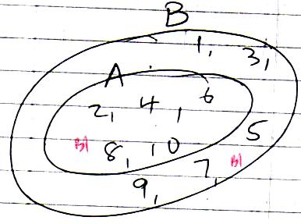Represent the two sets on a Venn- diagram.
2. Find the lowest common multiple (L.C.M) and the highest common factor (H.C.F) of 54 and 84

|  |  |  |
| --- | --- | --- |
| 2 | 54 | 84 |
| 2 | 27 | 42 |
| 3 | 27 | 21 |
| 7 | 9 | 7 |
| 9 | 9 | 1 |
|  | 1 | 1 |

H.C.F = 2X3

= 6

L.C.M = 22 x 3 7 x 9

= 756

1. Find the value of x given that.

C = K and C x N

C = K and C = RN

C =K + RN.

**SECTION B**

1. The cost per week of running a private school is partly a constant and partly varies directly with the number of pupils. It costs shs. 350,000 a week when there are 50 pupils and shs. 600, 000 a week when there are 100 pupils in the school if C is the cost and N is the number of Pupils.
2. Find the cost of running the school with 250 pupils a week.

350.000 = K + 50R – (i)

600.000 = K + 100R-(ii)

Solving simultaneously,

250,000 = 50R

R = 5000

350,000 = K + 250,000

K = 100,000

C = 100,000 + 5000 N.

For N = 250,

C = 100,000 + 5000 X 250

= Shs. 1,350,000

1. If in a certain week shs. 750,000 was spent,determine the number of pupils that attended that week

C = 750, 000, N=?

C = 100,000 + 5000 N

750,000 = 100,000 +5000 N

5000N = 650,000

N = 130

130 pupils

1. A group of 36 boys were asked which games they played from foot ball (F),Volley ball (V) and tennis (T) it was discovered that 12 play F, of which 2 play F and T only. An equal number of boys play V and T. 6 play F and V while 5play all the games. Those who play V and T only are one less than those who play F only and half those who did not play any of the three games.
2. Represent this information on a Venn diagram

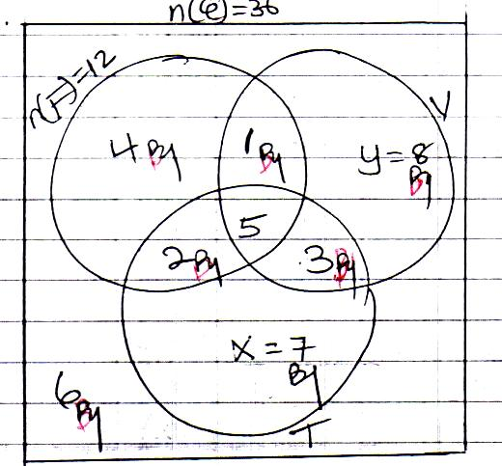n (F) only = 12 –(2 +5+1) = 4

n(v) = n(T)

y+ 145+ 3 + X+2+5+3

y+ 9 = x+ 10

y- X = 1. (1)

y = x + 1

Also

4+1+2+5+3+x+y+6 =36

21+ x +x+1 =36

2x +22 =36

2x =14

x =7

x=7, y =8

1. Find the number of boys who play
2. Tennis

17 boys

1. Only one game

19 boys

1. What is the probability that a boy chosen at random plays at most two games.

n (play at most one game )

=4+8+7+6

=25

Prob =

1. Town A is 130km from town B. A coaster left town A at 9.30am and because of jam it moved at a speed of 10kmh-1 for the first 1 hour. It then covered the next 90km in 1 ¼ hours before developing a mechanical problem which was rectified in 15 minutes. The coaster then sets off again and arrived at town B at 12:30pm.
2. Draw a distance – time graph showing the motion of the coaster.

(Use, scales of 1cm: 10km and 4cm: 1 hr)

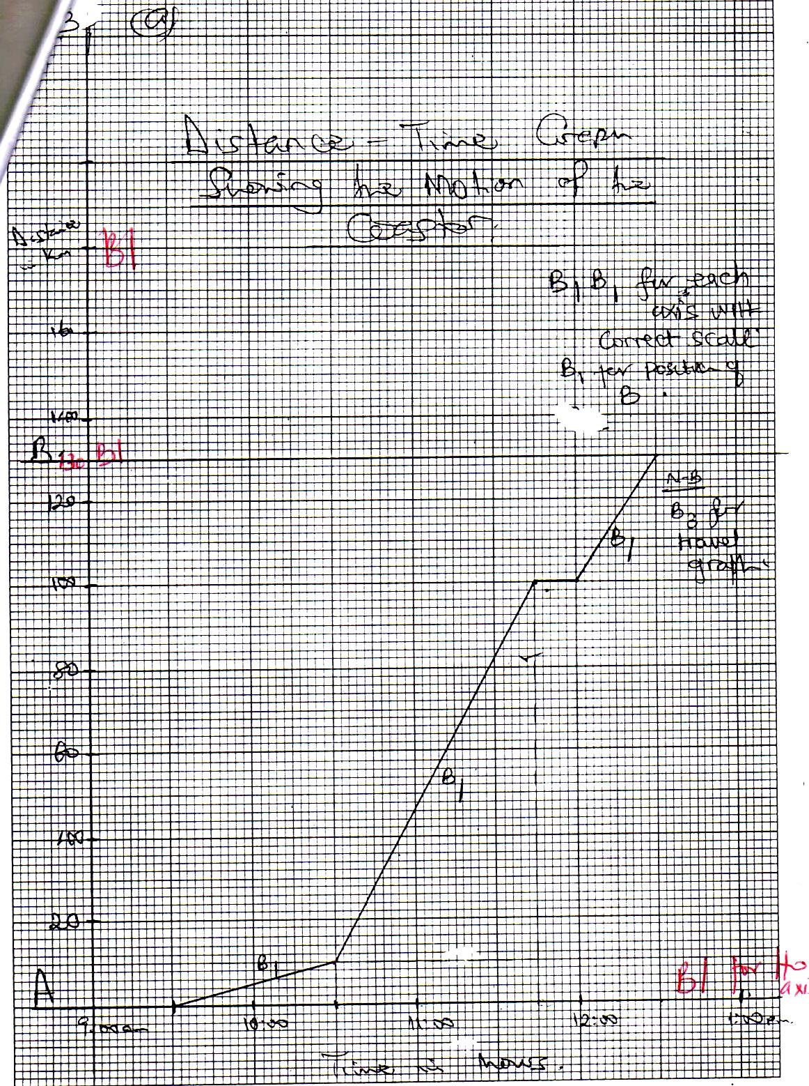

b) Find the speed of the coast

1. Before getting a mechanical problem

Speed =

=

= 72 km h -1

1. After rectifying the mechanical problem.

Speed =

=

= km h-1

c. Find the average speed of the coaster over the whole journey.

Average speed =

=

= km h -1

1. 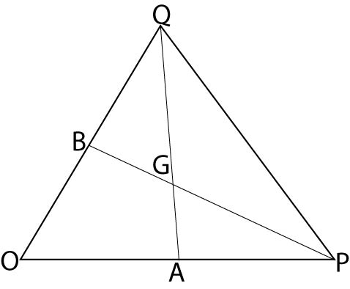

In the figure above

OPQ is a triangle such that

**OA** = 3***a*, OB**= 3***b*** and **OP** = 2***OA***, **OQ**= 2***OB*,** 3**AG**= and 5**PG**= 3**PG**

1. Find in terms of ***a***  and ***b*** the vector
2. **AB** = AO+ OB, or OB –OA

=-39+3b

Or 3b -39

1. **PQ** =PO +OQ OR OQ-OP

=-20A +20B

= -6a +6b

Or 6b -6a

1. OG = OA +AQ

but from 3AG =2 AQ

AG = AQ

and

***AQ = AO + OQ***

***=-***3a+ bb

AG = (-3A+6b)

**= -**29+ 4b.

OG = 3a +-2a + 4b

= 3a -2a+4b

= a+ 4b

From 3 AG =2AQ

AQ = AG

=(OG –OA)

= -3a)

AQ = (a+4b -3a)

= (-2a + 4b)

=3(-a+ 2b)

=-3a+6b.

1. Show that A, G and Q are collinear.

A, G, Q collinear

AQ =-3a +6b

AG= AQ

=(-3a + 6b).

AG and AG are parallel.

Since AG and AQ have common point, A, G, Q are collinear.

1. The table below shows the tax structure on taxable income of a certain working class of people

|  |  |
| --- | --- |
| **Income (shs) per month** | **Rate of tax (%)** |
| 15,001 – 40,000 | 8.00 |
| 40,001 – 70,000 | 12.50 |
| 70,001 – 120,000 | 15.50 |
| 120,001 – 200,000 | 24.00 |
| 200,001 – 350,000 | 30.00 |
| 350,001 – 420,000 | 35.00 |
| 420,001 – 500,000 | 45.00 |
| Above 500,000 | 48.00 |

An employee earning a gross income of shs 7,200,000 per annum is allowed the following;

Allowance Amount

Transport and lunch 45,000 per month

Housing 960,000 per annum

Water and electricity 25,000 per month

Medical care 900,000 per annum

Marriage of gross monthly income

The employee is allowed a family allowance for any three children according to the age distribution

|  |  |
| --- | --- |
| **Age** | **Amount (shs)** |
| 0 – 12 | 9000 |
| 13 – 18 | 5000 |
| 19 – 21 | 3500 |
| 22 – 25 | 2000 |

Given that this employee has a family of five children aged 23 years, 20 years, 17 years, 15 years and 8 years.

1. Calculate the employee’s income tax.

Gross monthly income =

= shs. 600,000

Allowances

Transport and lunch 45,000

Housing 80,000

Water & electricity 25,000

Medical + 75,000

Marriage x 600,000 30,000

Children 9000 + 2x 5000 19,000

Total allowances = 274,000

Taxable allowances =

Gross income – Allowances

= 600,000 – 274,000

= shs.326, 000.

Income tax;

Taxable income Tax

The 1st 15,000/= 0

On next 25,000/= x 25,000 = 2,000

Next 30,000/= X 30,000 = 3,750

Next 50,000/= x 50,000 =7,750

Next 80,000/= x 80,000 =19,200

Next 126,000/= X 126,000 =37,800

Total income tax = 2000 +3,750 + 7,750 +19,200 + 37,800

= Shs .70, 500

1. Determine the percentage of the employees taxable income that goes to tax

= X 100%

= x 100%

= 21.6258%

21.63%

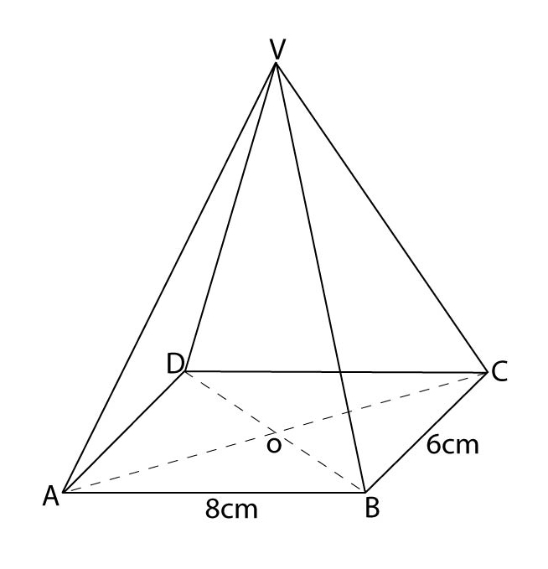

In the figure above = = =

= 8cm, = 6cm and V is vertically above O. If= 12cm, find

1. 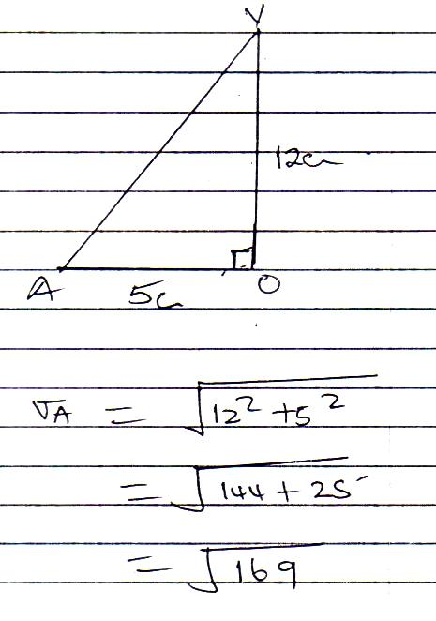The length VA

AC =

=

=10cm

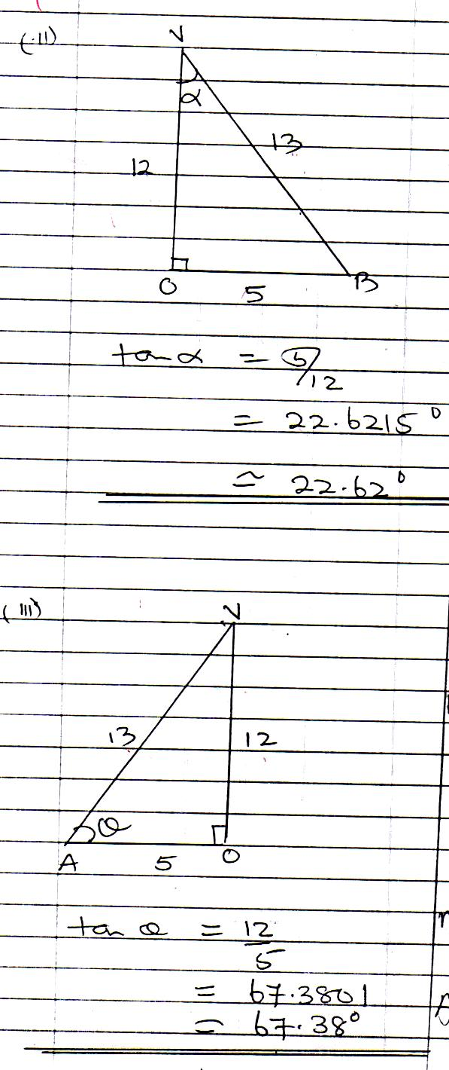

1. 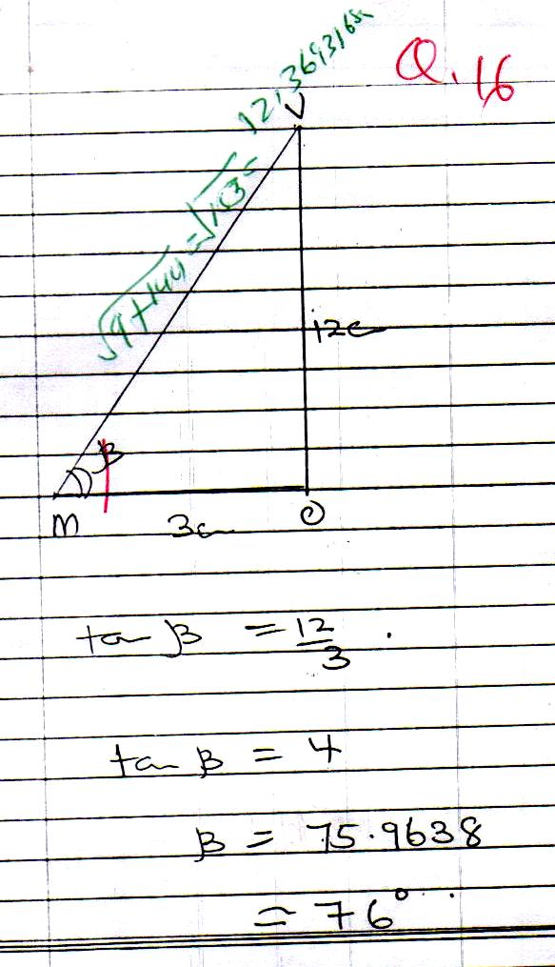The angle between the planes VAB and ABCD
2. (a) Given the functions f(x) = and g(x) = , determine the values of x for which

fg() =

f () =

g () =

fg () =f

= +3 2

= X

=.

=

16-2=9+24+82

82+ 24 +9=16-2

+24+2 +9-16=0

-

(b) If P:Q = 3:4 and Q:R = 1:2 and that P+Q+R = 30,000. Find

(i) The ratio P:Q:R

P: Q = 3:4

Q:R=1:2

=

= =

3:4:8.

(ii) The proportional parts of P,Q and R

A+ B+ C= 30,000

Total share =15

A gets x 36,000

= shs 6,000

B gets x 30,000

= shs 8,000

C gets x 30,000

=shs 16,000

**END**